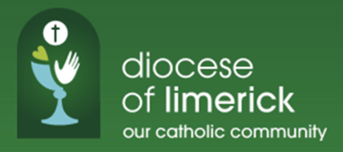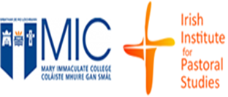

A PROGRAMME OF FORMATION
FOR LAY PASTORAL MINISTRY
AND LEADERSHIP

Name: _________________________________________________

Date of birth: _________________________________________________

Email Address: _________________________________________________

Phone No: __________________________________________________

Postal Address: ___________________________________________________
___________________________________________________
___________________________________________________
___________________________________________________

Name of Parish: ___________________________________________________

Name any involvement/roles you have had in your parish or local community.

_____________________________________________________________

_____________________________________________________________

_____________________________________________________________

Please list any course of study (if any) you have completed:

____________________________________________________________

____________________________________________________________

What is your present or most recent employment?

_____________________________________________________________

____________________________________________________________

Name any other relevant employments, roles or responsibilities, paid or voluntary, that have given you experience which may be helpful in this Ministry.

_______________________________________________________________

______________________________________________________________

_______________________________________________________________
_______________________________________________________________

What skills/learning/competencies have you gained from your work or study or voluntary involvement that will help you in this Ministry?

_______________________________________________________________

______________________________________________________________

_______________________________________________________________
_______________________________________________________________

How would you see yourself being involved after you complete the formation process?

_______________________________________________________________

______________________________________________________________

_______________________________________________________________
_______________________________________________________________

On a separate page, write 200 words on why you are applying for this Ministry.

Please provide the names and addresses of two people (one of whom must be a priest in your Parish or Pastoral Unit) whom we could contact for a reference.

- Name 2. Name

______________________________ ______________________________

Address: Address:

______________________________ ______________________________

______________________________ ______________________________

______________________________ ______________________________

______________________________ ______________________________

Contact No.: Contact No.:

______________________________ ______________________________

Email Address:

______________________________ ______________________________

Signature of Applicant: __________________________Date: _________________

Complete Application Form by Wednesday, October 9th 2024 and send to:

Fr Éamonn Fitzgibbon,
The Irish Institute for Pastoral Studies
Mary Immaculate College
St. Patrick's Campus,
Cathedral Street, Thurles,
Co. Tipperary

