Youth Ministry Coordinator
(Three-year fixed-term fulltime contract)

The Diocese of Limerick is a Catholic community of sixty parishes living and working together in service of the Gospel of Jesus Christ. Its geographical area comprises the greater part of County Limerick, part of County Clare and one townland in County Kerry. Eighteen of its parishes are located in the Limerick metropolitan area and environs. Services include the co-ordination and support of ministry, diocesan archives, pastoral supports, youth ministry, schools advisory services and safeguarding across the Diocese in a changing environment.

The Diocese is now recruiting a Youth Ministry Coordinator. The successful candidate will work on the delivery of the objectives and actions of the Young People theme in the Diocesan Pastoral Plan, the vision of which is: “ to create local opportunities for young people to meet their peers in the Eaglais Óg and replicate at local level, the success of the Youth Ministry at diocesan level and ensure that young people feel connected, involved and active in a multigenerational church whereby grandparents, parents and children minister to each other”.
The role will involve the creation, resourcing, delivery and support of youth ministry programmes and initiatives across the Diocese, including with parishes and schools with a focus on building capacity in the local context. It will also involve engagement with Youth Work and other relevant Organisations (Voluntary and Statutory) both Regionally and Nationally as appropriate.

Essential
- Relevant qualification and practical experience in either Catechetics, Religious Education, Youth Work, Youth Ministry or equivalent.
- Proven ability in working effectively and relating well with both young people and adults
- Demonstrable skills and experience in training and facilitation
- Ability to recruit, support and enable volunteers to work effectively with young people
- Demonstrable evidence of ability to develop, compile, deliver and evaluate training programmes
- Openness to work collaboratively with a range of stakeholders within and outside of the Diocese
- A commitment to personal faith development and promotion of Gospel values
- Familiarity with current and emerging directions in Youth Ministry
- Excellent organisational and planning skills
- Ability to work on own initiative as well as part of a team
- Excellent interpersonal and communication skills both oral and written
- Full clean driving licence and own transport
- Flexible attitude and willingness to travel as the work requires
- Openness and flexibility to adapt Youth Ministry programmes and activities to meet the changing needs of young people and the Diocese
Special requirements
- This role will involve a significant amount of evening, weekend and overnight work in support of training, residential and pilgrimage programmes
- Respect for the teachings of the Catholic Church

Completed application form (not CV) to be returned via electronic mail to: recruitment@limerickdiocese.org by the deadline of 12.00 noon on September 16th, 2022. The Diocese of Limerick may decide to extend this deadline, depending on the number of applications received by this date .
Please note that incomplete applications will not be considered.
A panel may be formed from the recruitment process that will expire after 1 year.
Garda Vetting will apply in respect of this position.
Shortlisting will apply and salary will be commensurate with qualifications/experience.
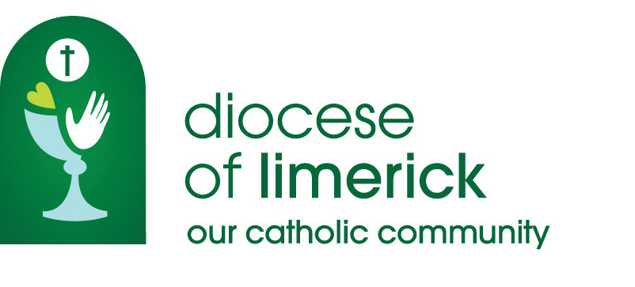
JOB DESCRIPTION

Position/Title: | YOUTH MINISTRY COORDINATOR
Summary of the Service | To create, resource, deliver and support youth ministry programmes and initiatives across the Diocese, working also with schools and parishes with a focus on building capacity in the local context. To deliver the objectives and actions of the young people theme in the Diocesan Pastoral Plan 2016-2026
Location: | Limerick Diocesan Centre, St. Munchin’s, Corbally, Limerick.
Main Duties | - Lead the development of youth ministry in the Diocese by identifying and responding to youth ministry needs at parish, pastoral unit and Diocesan level  - Work collaboratively with Diocesan teams, parishes, schools, youth and community organisations in understanding and addressing the faith needs of young people  - Joint planning, development, delivery and ongoing review of youth ministry in the Diocese of Limerick  - Joint delivery of the objectives and actions of the ‘Young People’ strand of the Diocesan Pastoral Plan ‘Moving forward together in hope’
Essential Requirements | - Familiarity with current directions in the mission of the Church in the area of Youth Ministry  - Catechetical, religious education, youth work or youth ministry experience with young people in parishes or schools as well as and practical training  - Commitment and energy to work with and relate well to young people as well as training, supporting and enabling volunteers to work effectively with them  - Facilitation and/or training skills and experience  - Excellent organisational and planning skills  - Ability to work on own initiative as well as part of a team  - A commitment to ongoing personal development  - Knowledge of and commitment to Safeguarding  - ICT and administrative skills including use of social media and Microsoft Office including Word, Excel and PowerPoint  - Full clean driving licence and own transport  - Flexible attitude and willingness to travel nationally as the work requires  - Openness and flexibility to adapt Youth Ministry programmes and activities to meet the changing needs of young people and the Diocese  - Representation of the Diocese on committees or groups as directed by the General Manager/Bishop  - Other duties as may be required from time to time

application form

Job Title Youth Ministry Coordinator
Location Diocesan Centre, St Munchin’s, Corbally Limerick
Closing Date for Application Friday, 16th September 2022 at 12.00 noon

Personal Details

Surname
Title
Forename(s)
Address
Postcode
E-mail
Tel. No.
Mobile
Current Salary
Where did you hear about this post?

Statement of suitability
(Please provide a detailed statement of why you think your skills and experience are suitable for this role, max 300 words)

Describe the skills & experience you possess in the following areas that would enable you to fulfil the role as described in the job description

Relevant qualification(s) and experience in the Youth Ministry or related field

Familiarity with and evidence of strong commitment to current directions in pastoral ministry of the Catholic Church in the area of Youth Ministry

Experience of working collaboratively to deliver programmes/activities

Evidence of facilitation and/or training skills

Evidence of organisational and planning skills

Evidence of ability to work on own initiative as well as part of a team
Experience of IT and social media skills

Employment Record
Please list brief particulars of the positions you held and experiences you obtained. Start with your present or most recent employer. Provide reasons for any gaps in your employment. (You may wish to submit this information in a sealed envelope with your name and marked “Confidential”).

Dates |  | Employers Name, Location  and Type of Business | Duties, Status and Nature of Work | Reason for Leaving
From | To

Educational Background
School | From | To | Examinations and Results
University/  College | From | To | Courses and Results
Further Education and Formal Training | From | To | Courses and Results

Additional Information
Please indicate any additional information which you feel may be helpful in assessing your suitability for the position

References
Please include details of your current/most recent employer and one other referee. Referees must not be related to you. Referees will not be contacted prior to interview.
Name and Position of Referee | Capacity in which known to Referee | Address, E-mail  and Telephone Number

Are you an Irish citizen or national of any EU country? Yes No
Do you need a work permit to work in Ireland? Yes No

Declaration
To the best of my knowledge and belief, the replies given to the questions on this application form are true and I have disclosed all information which I consider relevant. I hereby declare that there is no reason rendering me unsuitable to work with children or vulnerable adults. I understand that appointment will be subject to references, satisfactory Garda vetting and a medical. If I accept an offer of employment and any of the information is subsequently found to be incorrect, my employment may be terminated.
Signature of Applicant: Date:

Please complete all parts of this form and return by email to recruitment@limerickdiocese.org

by 12.00 noon on Friday, 16th September 2022

